

*Topic:*

***APPLICATION OF DATA SCIENCE IN BUSNIESS***

*AUTHOR’s:*

*Muhammad Hussain Khan*

**DATA SCIENCE:**

Data Science was born out of the necessity to process and analyses enormous amounts of data (Big Data). Big strides have been made in the creation of technologies that enable big data in recent years. Data analysis, model discovery, and advanced inference methods.

The terms "Big Data," "Data Analytics," and "Data Mining" all refer to both the data as well as the technologies used in data collecting, processing, management, and analysis procedures. Data mining is the process of looking for previously undiscovered, non-trivial, and practically relevant hidden data and patterns. Beneficial and essential for making decisions in a variety of human endeavors. The focus is not only on obtaining fresh information and developing testable hypotheses. Standard analytical tools are based on mathematical statistics, including decision trees, regression, correlation, and grouping, artificial intelligence methods include machine learning, neural networks, genetic Ontological engineering, fuzzy logics, and algorithms, etc.

Building, purifying, and organizing databases for analysis and meaning extraction is the process of data science. Data analytics, which is the process of analyzing and understanding data, should not be confused with this. Both of these procedures are useful in the business and have many similarities. Building, purifying, and organizing databases for analysis and meaning extraction is the process of data science. Data analytics, which is the process of analyzing and understanding data, should not be confused with this. Both of these procedures are useful in the business and have many similarities.

For data science, you must:

* Create hypotheses
* Conduct tests to acquire information
* Analyze the data's quality
* tidy, well-organized datasets
* Structure and organize data for analysis.

To gather and analysis huge data, data scientists frequently create algorithms in coding languages like SQL and R and also in Python. Algorithms can spot information or trends that humans miss if they are properly developed and carefully tested. They can also considerably quicken the data collection and analysis procedures.

For instance, a researcher-developed algorithm can be used to identify changes between 3D medical pictures, such as MRI scans, more quickly than a human could. Doctors may be able to save patients' lives by responding to urgent problems identified by the scans due to the time saved.

Critical thinking is more important as a result of this new world of possibilities, according to Tingley. "None of these seemingly magical machine-learning applications would be viable without human thought and supervision throughout the entire process.

Here are five data science tools your company can use if you want to interpret huge data and use it to have an impact.

**SOME DATA SCIENCE APPLICATIONS IN BUSINESS**

* Forecast Market Trends
* Streamline Production
* Obtain client insights
* Inform internal finances as well as increasing security

**Forecast Market Trends:**

The Fourth Industrial Revolution stands apart from the previous ones in essential ways due to the convergence of the real and virtual worlds as well as social groups. The evolution of leading technologies into what are now referred to as "emerging technologies" are prerequisites for its construction. Industry 4.0 places a strong emphasis on the need for fresh ideas and techniques to help present and future generations develop their awareness, knowledge, and skills in order to benefit from technology advancements. All of this results in new issues and the need for novel approaches to managing and analyzing massive amounts of data.

Our expertise is in the processing of gathered data in e-learning methods for evaluating students' knowledge, abilities, and competences in the online learning environment of emerging technologies, with opportunities for adaptation to new tools and applications. The created models can be used to predict the grades of new students. From the Evaluate menu, select the Predictions tool, which predicts the data from the submitted file and determines the value of the undefined column - an estimate provided by the created model. The following is an assessment of the accuracy of the models. A workflow related to model evaluation using the Test & Score and Confusion Matrix tools is shown in Figure. 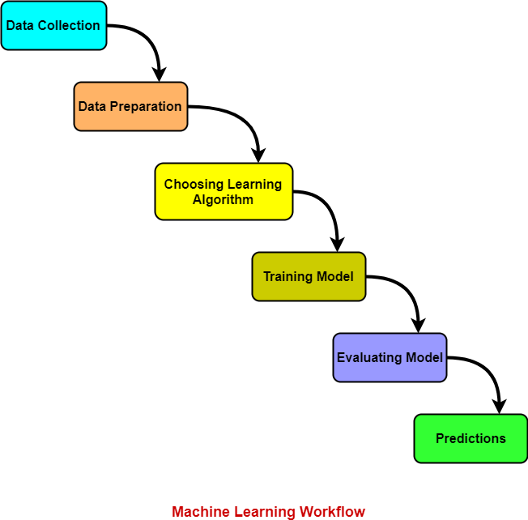

A sheet with rankings for the produced models' Accuracy, Precision, Recall (sensitivity), and F1 Score is the output of the Trial & Report tool's operation. Figure 2 displays specific estimations of the developed models.

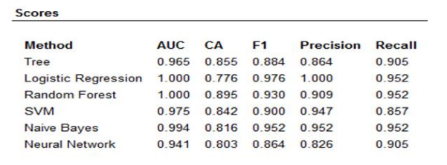

The Random Forest model is shown to have the maximum accuracy for all assessment classes, making it the most trustworthy in this situation. When compared with other models in the data taken into consideration, the Naive Bayes model has the lowest accuracy rating. Figure displays the outcomes of the Confusion Matrix Tool's operation for both models.

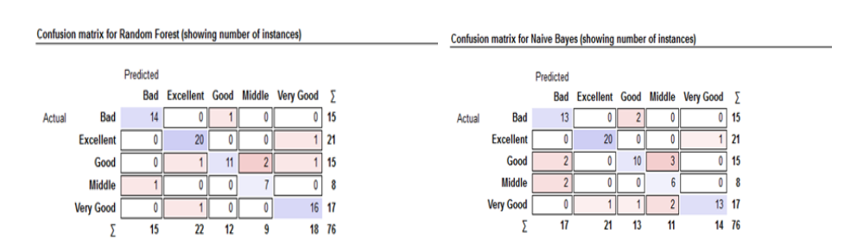

**Results of the work the of the instrument Confusion matrix over the created models.**

The classification algorithms Decision Tree and Random Forest, which accurately anticipate the components of the class Bad, can be used in assessment issues that are similar to these. These pupils are those deemed to be "students at critical zone," meaning they have low marks.

**Streamline Production (Improve Production):**

Finding inefficiencies in production processes is another approach to use data science in business. High amounts of data are collected from production operations by manufacturing machines. An algorithm can be created to quickly and accurately clean, organize, and analyze large amounts of collected data that are too complex for a people to manually evaluate.

Life cycle analysis (LCA) is a time- and labor-intensive process by nature. The collection of data for a large number of different processes is often required when creating life cycle inventory (LCI) using a standard process analysis. Input-output analysis and hybrid analysis, two more thorough LCI techniques, can each incorporate data for trillions of individual transactions or transactions/processes, respectively. These two techniques are recognized to give a far more thorough overview of a product's supply chain and associated environmental flows, but they also make an LCA more difficult and time-consuming. This has hindered the adoption of more thorough LCI methodologies, possibly resulting in poorly informed environmental decision-making. To enable a hybrid LCI's wider application, a more user-friendly method of compilation is required.

**How to Improve a Production Schedule Using Data Science:**

What and how much produce? and other crucial concerns are addressed by a factory production schedule system.

where to create considering the available resources?

where may the finished project be kept?

When should you wait and reassign resources?

**Importance of Data in Production Scheduling:**

The adage "Garbage in, garbage out" describes what happens when the quality of your input data is poor. Your production scheduling system's effectiveness will depend on the calibre of the inputs it gets, regardless of whether it is based on heuristics or quantitative optimization. Unreliable inputs will inevitably result in suboptimal schedules or ones that may be impossible to implement because they violate production limitations.

Integrating DS techniques can help you organise your data so that you can provide better results more quickly than with conventional techniques. With only a slight reduction in solution quality, machine learning and artificial intelligence algorithms can frequently develop production schedules quite quickly. We outline how data science can improve production scheduling systems in the paragraphs below:

* Enhance forecasts: Utilize statistical time series analysis or deep supervised learning techniques to more accurately estimate consumer demand and raw material availability. A product scheduling system produces greater results when its inputs are better.
* Predict resource availability by employing time-to-event analysis to model the health of the equipment and anticipated maintenance downtimes. You can minimise the disturbance to production schedules and maximise the utilisation of the available resources by planning for the availability or unavailability of machines.

Gain Customer Insight:

Consumer insight, often referred to as customer insight, is the comprehension and interpretation of consumer data, actions, and feedback into conclusions that may be used to enhance product development and customer service. The reasoning underlying client demands and needs that can be used to increase features, create new products, and improve consumer benefits are known as insights. The goal of gathering customer insights is to match a company's commercial objectives with its customers' demands.

Brands gather enormous amounts of customer data in order to acquire customer insights and stay competitive as surveillance technology develops, gets more data rich, less intrusive, and less expensive. Brands frequently undertake consumer surveillance without taking into account the effects on customer relationships. Customers may face privacy invasions as a result of customer surveillance operations and resort to customer secrecy tactics that obfuscate or conceal their data. We suggest a set of surveillance prompts to structure market intelligence databases to increase the effectiveness of customer surveillance activities and thereby reduce the number of such activities while increasing data integrity and the potential value of customer insights in order to lessen this reaction.

Customer data is abundant because to clever products, social media, and inventive market research, but it is dispersed across the organization due to its diverse sources and structures. Customer insights can be greatly improved by combining these many sorts of data, which would not have been achievable through individual analysis. It enables rapid product development with genuinely unique solutions that are suited to the consumer and is a key step for the shift from the present primarily hypothesis-based product design approach to a data-driven one. This essay describes how to detect consumer needs and requirements holistically using a concept called the "digital shadow of the customer." It is an idea that was adopted from the Internet of Production and its virtual representations of goods and operations.

**References:**

* Ahituv N 2019 What Should be Taught in an Academic Program of Data Sciences
* Hornick M Marcade E Venkayala S 2006 Java data mining
* Mustafa Yağcı, Kırşehir Ahi Evran University, Faculty of Engineering and Architecture, 40100, Kırşehir, Turkey
* André Stephan Robert H. Crawford & Paul-Antoine Bontinck
* Scott Sachs , Kirk Plangger Richard , T.Watson
* Robert H. Schmitt, Raphael Kiesel
* Marie Lindemann , Kristof Briele.